|  |  |  |  |
| --- | --- | --- | --- |
| \\lyng-dc1\StaffShared\Learning Bugs Animals ALL subjects\characters bugs animals\Cyril the Snail - History.jpeg**Lyng Primary School Knowledge Organiser** | | | |
| **History Topic:** | **What was life like in Ancient Greece?** | Year 3  *Battles, Beliefs and Buildings* | Spring 2 |

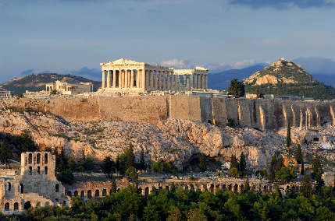

The Ancient Greeks lived around 3,500 years ago their legacy shapes the world we live in today. For some people, life in Greece was good, and many lived in busy towns and cities. They build many temples and very important building that all stood on hills.

|  |  |
| --- | --- |
| **What Step On and Goldilocks words will I use?** | |
| **Spelling** | **Definition** |
| architecture | The art or practise of designing and constructing buildings. |
| Athens | One of the most powerful Greek city-states, Athens was the birthplace of democracy. |
| deity | A god or goddess |
| democracy | A fair political system where all adults vote for an elected government. |
| hoplite | A solider in the Greek army who fought with a long spear and used a large, round shield for protection. |
| military | Relating to or belonging to the army. |
| mythology | A group of myths, especially all the myths from a particular country, religion, or culture. |
| Olympics | An athletic event held by the Ancient Greeks every four years. |
| Titans | The Titans were the first Greek gods. |
| Phalanx | Greek army formation. |
| Spartans | Tough warriors living in the Greek city of Sparta. |
| warfare | The activity of fighting a war. |
| Zeus | Zeus was the king of the Greek gods who lived on Mount Olympus. He was the god of the sky and thunder. |

|  |  |
| --- | --- |
| **When? (Timeline of key events)** | |
| 776 BC | The year of the first Olympic games. |
| 508 BC | Democracy begins in Athens. |
| 490 BC | The Greeks defeat the Persian invaders at the battle of Marathon. |
| 472 BC | Theatres become popular in Greece. |
| 432 BC | The Parthenon in Greece was completed. |
| 431 BC | Sparta defeats Athens. |
| 333 BC –  323 BC | Alexander the Great defeats many countries. |
| 146 BC | Rome conquers Greece and becomes part of the Roman Empire. |

**Hook**

Greek Olympics

*Children to take part in their own mini Olympic games*

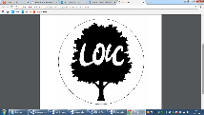

Happiness is the meaning and purpose of life – Aristotle

**Great Quotes**

**Focus Text**

**Our Storytelling Approach to enhance engagement**

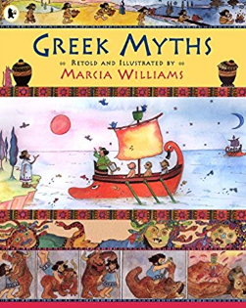

|  |  |  |
| --- | --- | --- |
| **People:**  The Greeks | **Place:**  City of Troy | **Problem:**  Queen of Sparta has been kidnapped |

**Key Facts and Famous Figures**

**The Trojan Horse**

The Trojan Horse is a large wooden horse from the Trojan War in Greek mythology. In the Trojan War, the Greeks were fighting against the city of Troy. The war started when Helen, the queen of Sparta, was kidnapped by Paris, prince of Troy. The Greeks waged war on Troy to win Helen of Troy back.

**Greek soldiers**

The Ancient Greek city-states often fought each other. Sometimes groups of city-states would unite to fight other groups of city-states in large wars. Rarely, the Greek city-states would unite together to fight a common enemy such as the Persians in the Persian Wars. All the men living in a Greek city-state were expected to fight in the army. In most cases, these weren't full time soldiers, but men who owned land or businesses who were fighting to defend their property.

**Greek Gods**

The Titans were the first or elder gods. There were twelve of them including the parents of Zeus, Cronus and Rhea. They ruled during what was called the golden age. They were overthrown by their children, led by Zeus.

tribes who fought each other for more land and power.

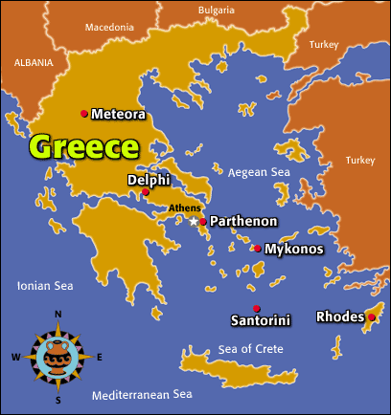

**Key skills – Taken from Milestone 2 – Sequence of Learning**

* Describe the characteristic features of the past, including ideas, beliefs, attitudes and experiences of men, women and children.
* Describe the social, ethnic, cultural or religious diversity of past society.
* Compare some of the times studied with those of other areas of interest around the world.
* Use literacy, numeracy and computing skills to a good standard in order to communicate information about the past.
* Describe different accounts of a historical event, explaining some of the reasons why the accounts may differ.
* Suggest causes and consequences of some of the main events and changes in history.

**Agreed Outcome**

3D model temple

|  |  |  |  |
| --- | --- | --- | --- |
| \\lyng-dc1\StaffShared\Learning Bugs Animals ALL subjects\characters bugs animals\Cyril the Snail - History.jpeg**Lyng Primary School Knowledge Quiz** | | | |
| **History Topic:** | **Ancient Greeks** | Year 3  *Battles, Beliefs and Buildings* | Spring 2 |

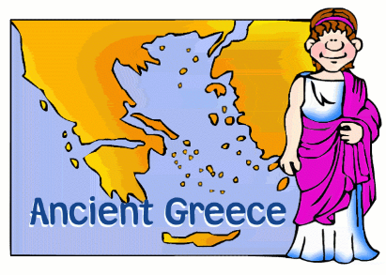

|  |  |  |
| --- | --- | --- |
| 5) Which of these was NOT a Greek building? | **S** | **E** |
| 1. Pyramid of Giza |  |  |
| 1. Acropolis |  |  |
| 1. Parthenon |  |  |

|  |  |  |  |
| --- | --- | --- | --- |
| 6) Name the three different type of Greek columns. | **S** | **E** | |
|  | | |

|  |
| --- |
| 7) The Trojans won the Battle of Troy. True or false? |
| Start: |
| End: |

|  |  |  |
| --- | --- | --- |
| 10) The Romans invaded Greece. | **S** | **E** |
| True |  |  |
| False |  |  |

|  |  |  |
| --- | --- | --- |
| 1. Why did the Ancient Greeks invent the Olympics? | **S** | **E** |
| 1. Celebrate sports |  |  |
| 1. Honour Zeus |  |  |
| 1. To enter the afterlife |  |  |

**Ancient Greeks Quiz**

|  |  |  |
| --- | --- | --- |
| 1. Which ones of these is a Greek God? | **S** | **E** |
| 1. Apollo |  |  |
| 1. Nut |  |  |
| 1. Hunter gatherer |  |  |

|  |  |  |
| --- | --- | --- |
| 1. Hoplites fought with… | **S** | **E** |
| 1. Wooden clubs |  |  |
| 1. Spells |  |  |
| 1. Spears |  |  |

**Start:**

**End:**

|  |  |  |
| --- | --- | --- |
| 1. What is a deity? | **S** | **E** |
| 1. Stone Age weapon |  |  |
| 1. Building in Ancient Greece |  |  |
| 1. God or goddess |  |  |